Crop Recommendation Data Analysis Report
Exploratory Data Analysis, Cleaning, & Visual Insights
1. Executive Summary & Data Integrity Analysis
This report presents a thorough exploratory analysis and visual diagnosis of the Crop Recommendation dataset. The primary objective is to evaluate soil nutritional parameters (Nitrogen, Phosphorus, Potassium) alongside climatic factors (Temperature, Humidity, pH, and Rainfall) to understand crop growth requirements.

Metric / Feature | Data Type | Missing Values | Observed Range
Nitrogen (N) | Integer | 0 (0%) | 0 - 140 ratio
Phosphorus (P) | Integer | 0 (0%) | 5 - 145 ratio
Potassium (K) | Integer | 0 (0%) | 5 - 205 ratio
Temperature | Float | 0 (0%) | 8.83 - 43.68 °C
Humidity | Float | 0 (0%) | 14.26 - 99.98 %
pH Level | Float | 0 (0%) | 3.50 - 9.94 pH
Rainfall | Float | 0 (0%) | 20.21 - 298.56 mm
Label (Target) | String (22 classes) | 0 (0%) | 100 samples / crop

Data cleaning verified that the dataset is balanced and complete with 2,200 records. No null values, formatting errors, or duplicate entries were present.
2. Visual Insights & Agricultural Analysis
Insight 1: Feature Correlation Heatmap
A strong positive correlation (r = 0.74) exists between Phosphorus (P) and Potassium (K). Environmental factors like temperature, humidity, and rainfall display lower correlation with individual soil nutrient levels, proving they act as independent environmental drivers.

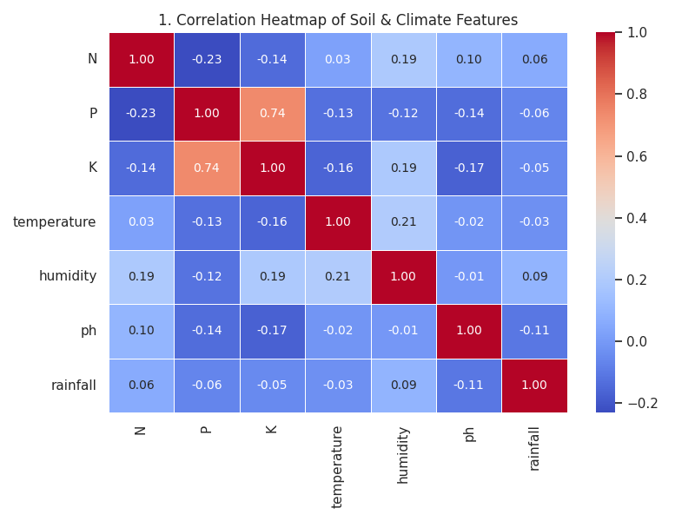
Figure 1: Correlation Matrix across Soil and Climate Variables
Insight 2: Top Nitrogen-Hungry Crops
Cotton leads nitrogen demand (N > 115), followed by Coffee, Muskmelon, Banana, and Watermelon. These crops require substantial nitrogenous fertilizer management for optimal vegetative growth.
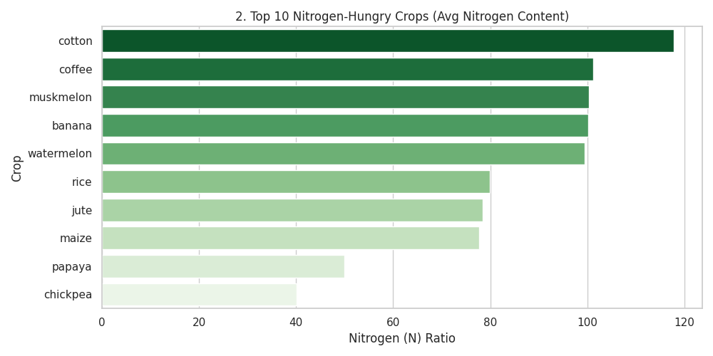
Figure 2: Top 10 Nitrogen Demanding Crops (Average Ratio)

Insight 3: Top Potassium-Hungry Crops
Grapes and Apples exhibit extreme Potassium requirements (K ≈ 200), vastly exceeding other crops. Potassium plays a pivotal role in fruit development, water regulation, and sugar accumulation.
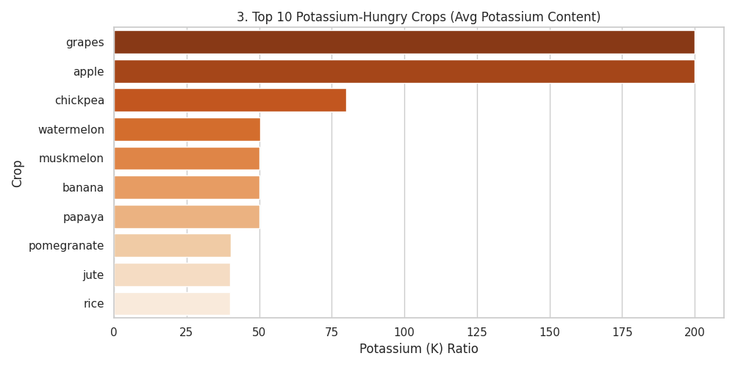
Figure 3: Top 10 Potassium Demanding Crops (Average Ratio)
Insight 4: Top Phosphorus-Hungry Crops
Apples and Grapes also require the highest Phosphorus amounts (P > 130), followed by legumes like Lentils and Chickpeas. Phosphorus is critical for robust root development and energy transfer.
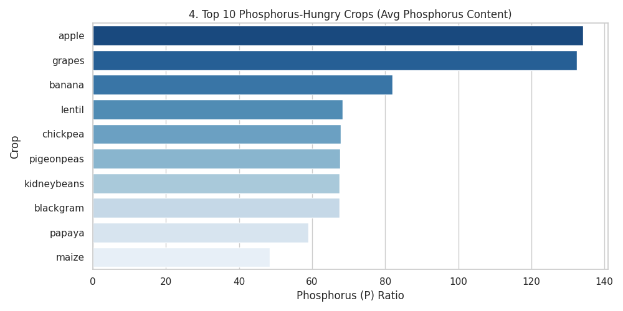
Figure 4: Top 10 Phosphorus Demanding Crops (Average Ratio)

Insight 5: Rainfall & Humidity Clustering
Crops form distinct climatic niches. Rice, Coconut, and Jute thrive in high humidity (>80%) and high rainfall (>150mm) conditions, while leguminous crops prefer drier, moderately humid environments.
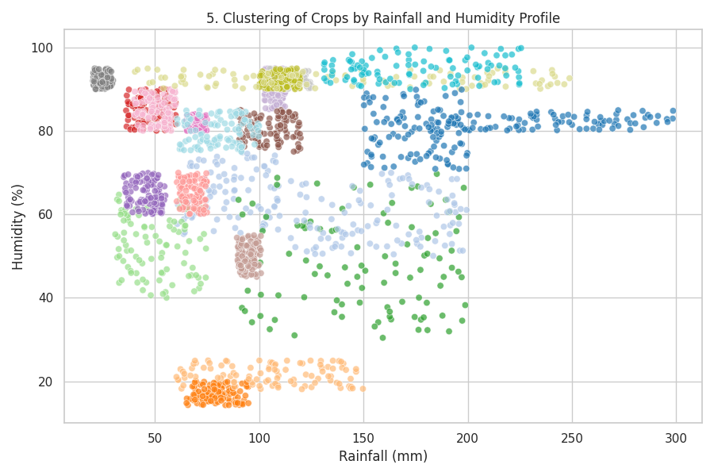
Figure 5: Environmental Clustering by Rainfall and Humidity
Insight 6: Temperature Range Preferences
Papaya and Pigeonpeas tolerate elevated temperatures up to 40°C+. Conversely, crops like Muskmelon and Mungbean require tight, controlled warm temperature bands.
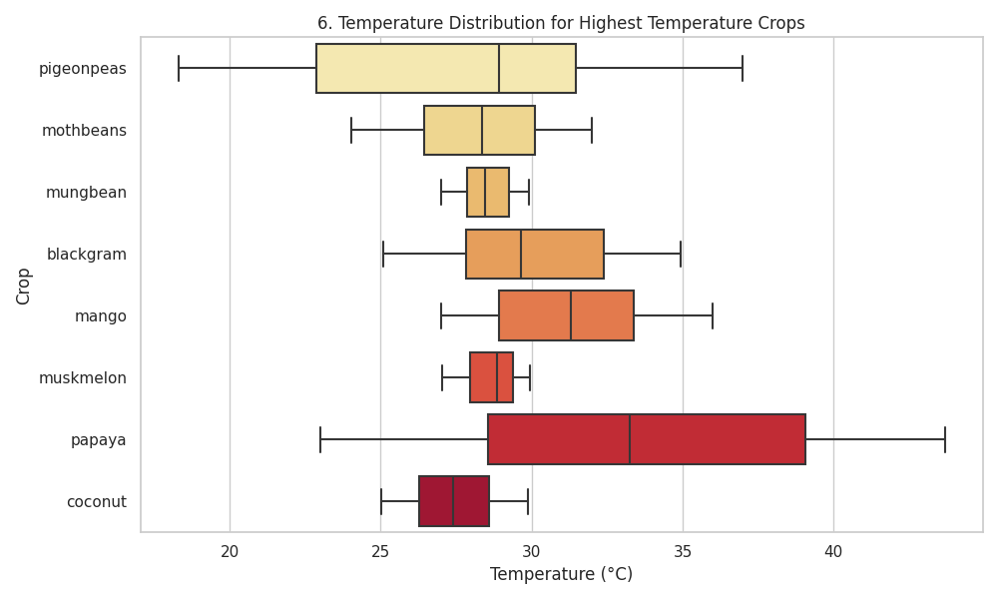
Figure 6: Temperature Distribution Across Selective High-Temp Crops
Insight 7: Soil pH Tolerance & Preferences

Chickpeas favor slightly alkaline soils (pH up to 8.8), whereas Pigeonpeas and Mangoes demonstrate higher tolerance to acidic soils (pH < 5.5). Most crops remain centered in the neutral range (6.0 - 7.5).
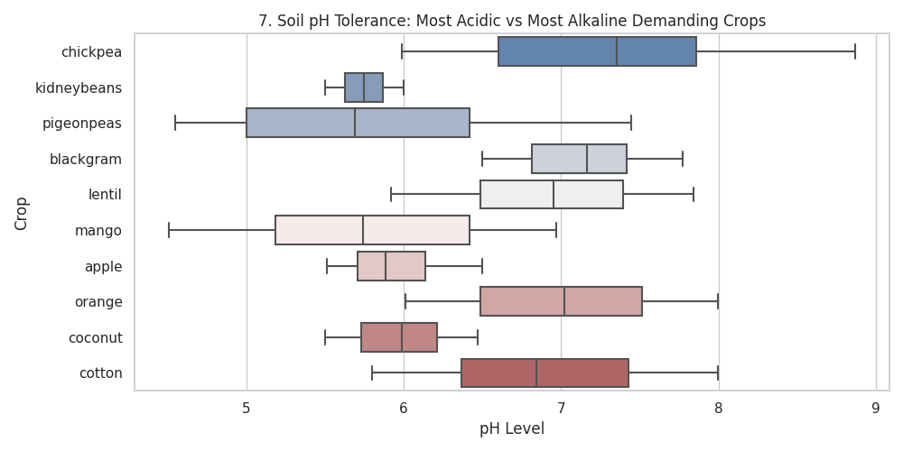
Figure 7: Soil pH Range for Acidic vs. Alkaline Tolerant Crops
Insight 8: Phosphorus vs Potassium Nutrient Clustering
Visualizing P versus K reveals isolated clusters. Apple and Grape cultivars occupy a high P/K cluster, distinct from general agricultural crops, facilitating distinct fertilizer profiling.
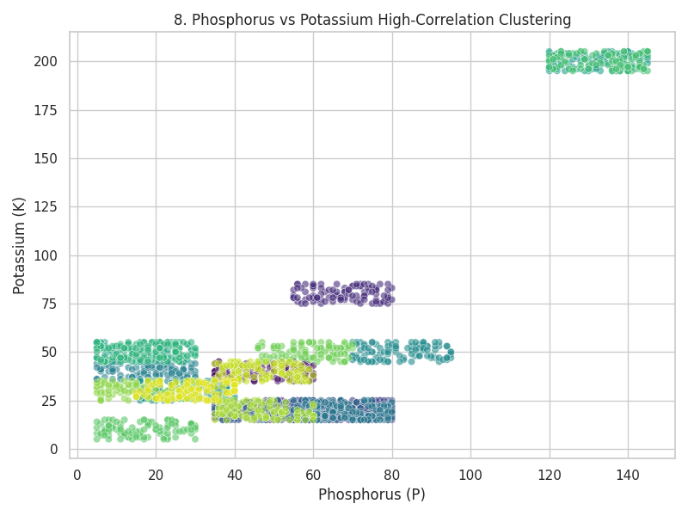
Figure 8: P vs K Scatter Plot Showing Distinct Agronomic Clusters
Insight 9: Environmental & Soil Parameter Distributions
Soil pH and Temperature approximate normal distributions. Rainfall, Phosphorus, and Potassium exhibit right-skewed distributions caused by specific high-requirement crop outliers.
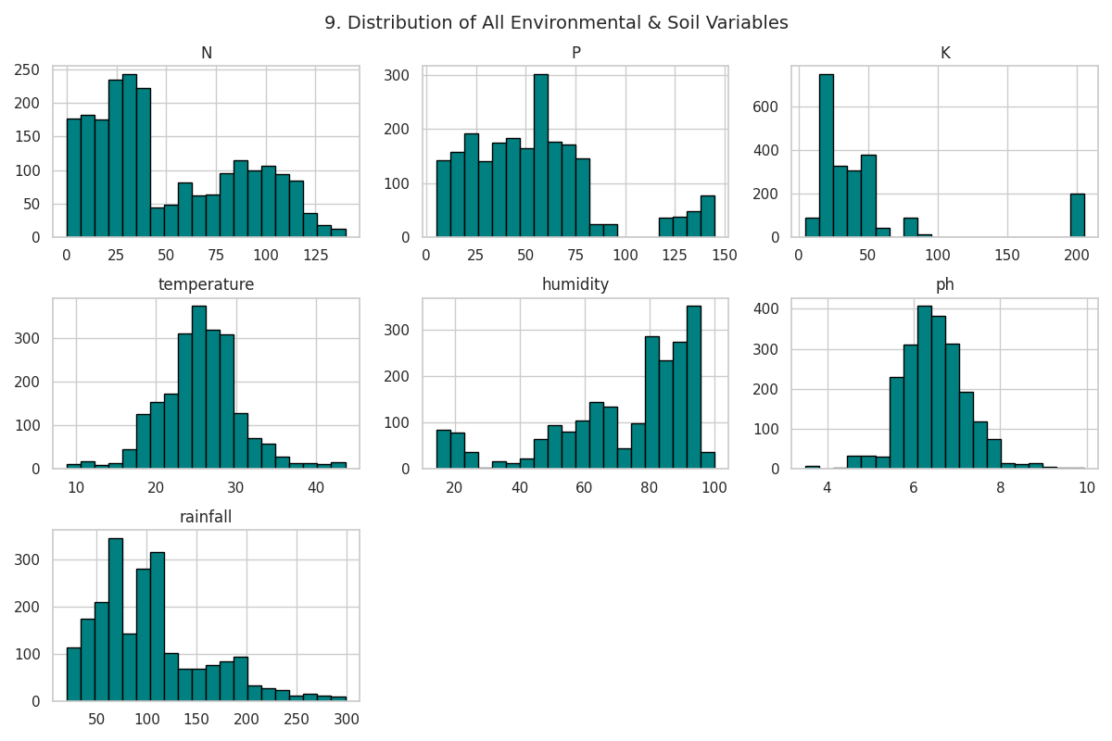
Figure 9: Histograms of Feature Distributions
Insight 10: High-Rainfall Requirement Crops
Rice requires the highest average rainfall (~236mm), followed by Coconut (~175mm) and Jute (~174mm). These crops depend on heavy irrigation or monsoonal rainfall regions.
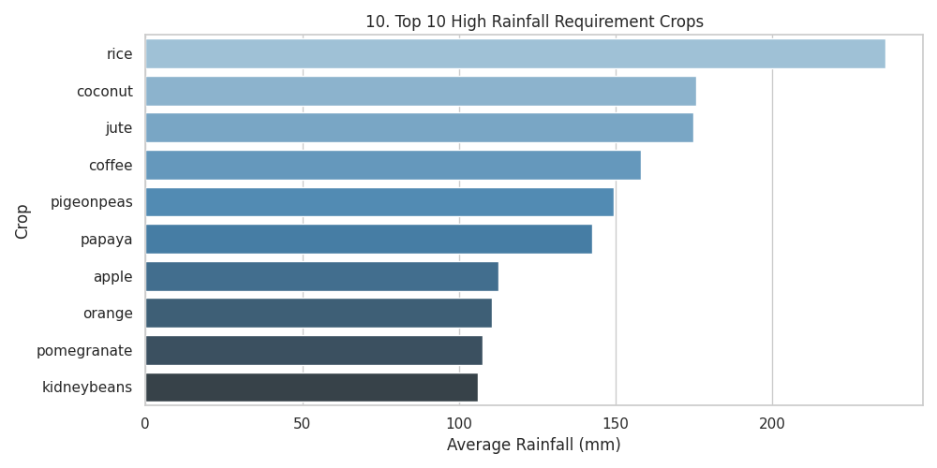
Figure 10: Top 10 Water-Intensive Crops
Insight 11: Humidity VS Temperature
It shows that clear environment clustering where different crop species occupy specific temperature and humidity.
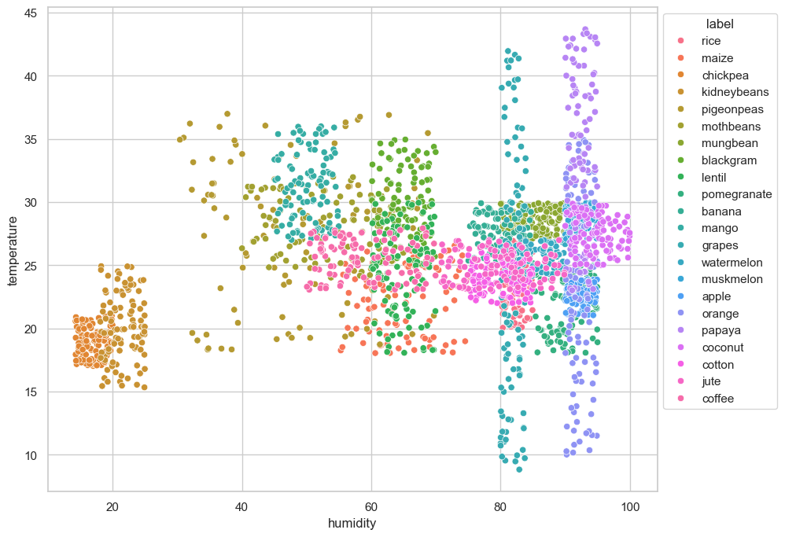
Figure 11: Humidity VS Temperature for different crop

3. Agronomic Recommendations & Key Takeaways
- Targeted Fertilization: Specific fertilizer blends should be formulated for fruit crops like Apple and Grape due to their extreme P and K requirements.
- Irrigation Planning: Water allocation models must prioritize Rice, Coconut, and Jute during dry spells, as their minimum rainfall thresholds are twice those of standard crops.
- Soil Amendment: Soil pH conditioning (e.g., liming acidic soils for Chickpeas) is recommended prior to planting pH-sensitive crops.

